 C4.7
Trigonometry crossword

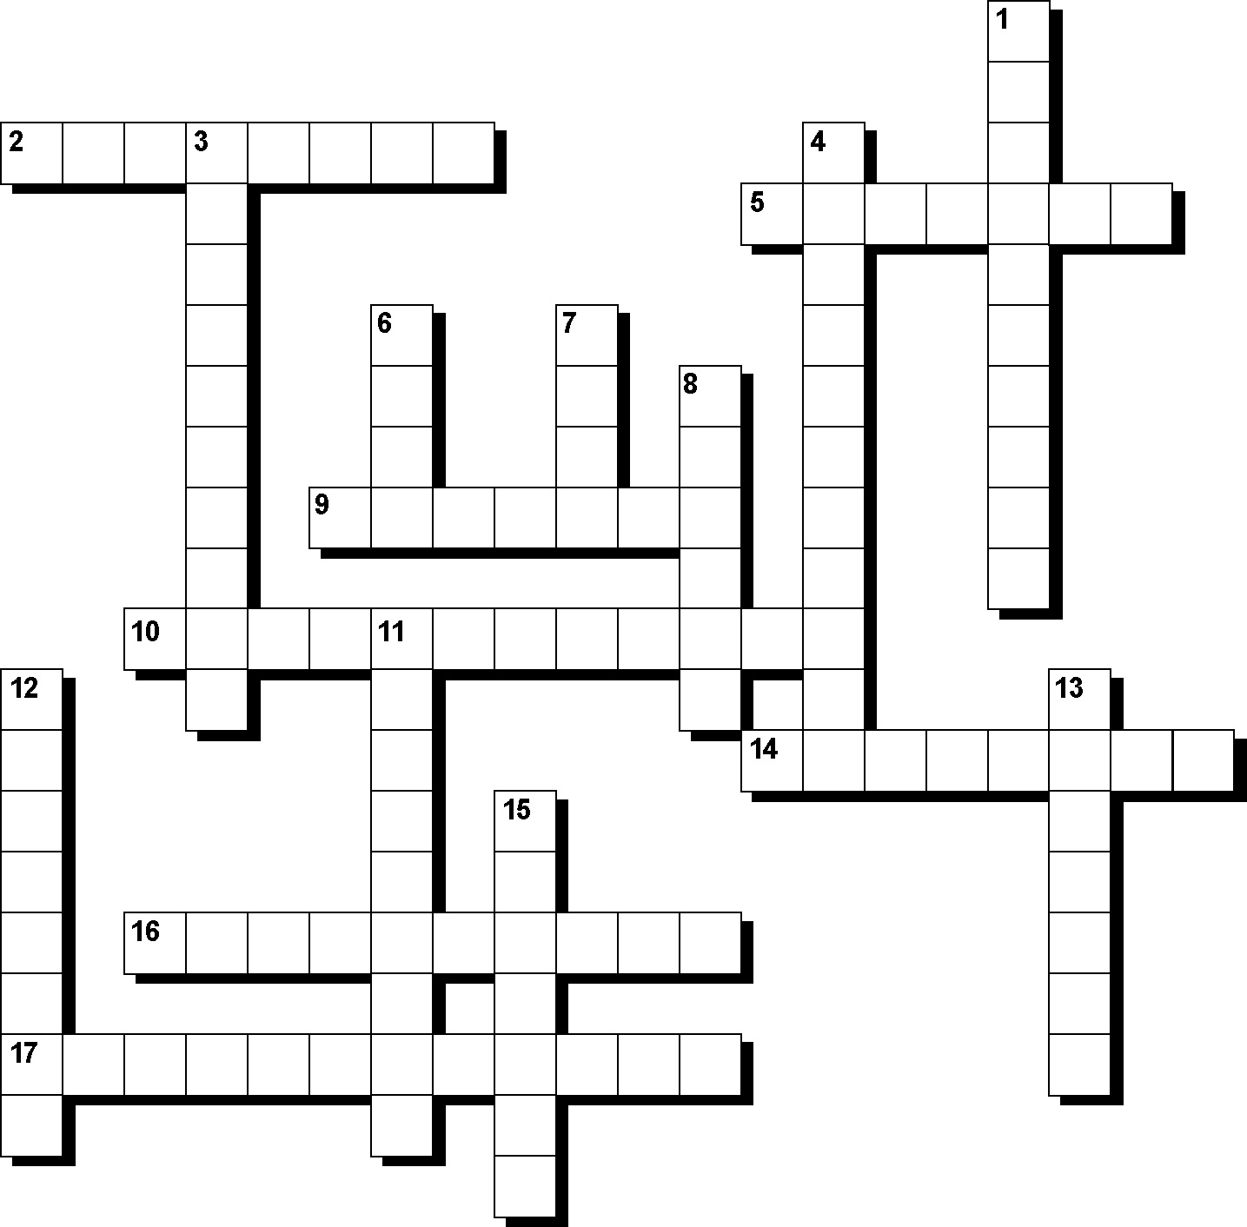

Across
2. Each quarter of the unit circle is called this. (8)
5. Used instead of decimal points for angles, this word uses the symbol ′. (7)
9. There are 360 of these in a full rotation. (7)
10. Bearings in the style of N 20º E are called _________ bearings. (12)
14. A side of a triangle that forms the angle being used. (8)
16. The longest side of a right-angled triangle. (10)
17. A maths topic that involves the relationship between sides and angles of right-angled triangles. (12)
Down
1. A circle with a radius of 1 unit. (10)
3. The angle looking downwards from a horizontal line is called the angle of ___________. (10)
4. A triangle with one angle equal to 90 degrees. (11)
6. Bearings that show the clockwise rotation from north are called _________ bearings. (4)
7. Trigonometric ratio that uses the hypotenuse and the opposite side. (4)
8. Trigonometric ratio that uses the hypotenuse and the adjacent side. (6)
11. The angle looking upwards from a horizontal line is called the angle of ____________. (9)
12. A side that doesn’t form the angle being used. (8)
13. Used instead of decimal points for angles, this word uses the symbol ". (7)
15. Trigonometric ratio that uses the opposite and adjacent sides. (7)

